# Auto Trace & Explain Plan

## Task 1: Auto Trace configuration training

Below all possible variants of SQL plus utilities autotrace:

set autotrace off

set autotrace on

set autotrace traceonly

set autotrace on explain

set autotrace on statistics

set autotrace on explain statistics

set autotrace traceonly explain

set autotrace traceonly statistics

set autotrace traceonly explain statistics

set autotrace off explain

set autotrace off statistics

set autotrace off explain statistics

**NOTE:** If you received next error: Check PLUSTRACE role is enabled. Please make next steps:

1. Run next script connected as sysdba:

# @ $ORACLE_HOME/sqlplus/admin/plustrce.sql;

1. Grant role PLUSTRACE to $UserName$

# grant plustrace to $UserName$;

**Task Results:**

Expected:

Summary table with all result and text description of analyses this results.

|  |  |  |
| --- | --- | --- |
| № | Auto Trace Configuration Options | Description |
| 1 | set autotrace off | No AUTOTRACE report is generated. This is the default. |
| 2 | set autotrace on | The AUTOTRACE report includes both the optimizer execution path and the  SQL statement execution statistics. |
| 3 | set autotrace traceonly | Like SET AUTOTRACE ON, but suppresses the printing of the user's query  output, if any. |
| 4 | set autotrace on explain | The AUTOTRACE report shows only the optimizer execution path |
| 5 | set autotrace on statistics | The AUTOTRACE report shows only the SQL statement execution  statistics. |
| 6 | set autotrace on explain statistics | The AUTOTRACE report shows the optimizer execution path and the SQL statement execution  statistics. |
| 7 | set autotrace traceonly explain | The AUTOTRACE report shows only the optimizer execution path but doesn't print a query's result. |
| 8 | set autotrace traceonly statistics | The AUTOTRACE report shows only the SQL statement execution statistics but doesn't print a query's result. |
| 9 | set autotrace traceonly explain statistics | The AUTOTRACE report shows the optimizer execution path and the SQL statement execution statistics but doesn't print a query's result. |
| 10 | set autotrace off explain | Turns off execution plan reporting. |
| 11 | set autotrace off statistics | Turns off execution statistics reporting |
| 12 | set autotrace off explain statistics | Turns off execution plan reporting and execution statistics reporting. |

# Join Methods

**The Main Task** is to create SQL and prepare execution plan of statements with join methods on Task Topics (Task 2 - 9)

**Task Results:**

There are several tasks below with the same main expected result points:

* Create SQL using next tables: scott.emp, scott.dept
* Create additional needed Tables and Indexes
* Prepare screenshots of execution plan

## Task 2: Nested Loops Joins

**Example:**

# SELECT /* USE_NL (d e) */ * FROM scott.emp e, scott.dept d WHERE e.deptno = d.deptno AND d.deptno=10;

**Task:** Prepare SQL **explain plan** using: SQL plus Auto Trace Utility.

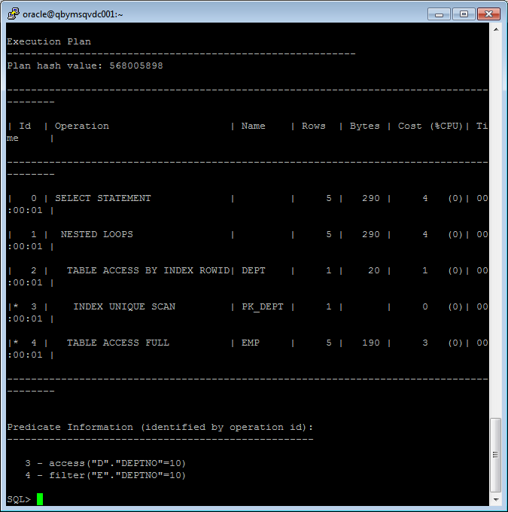

**Note:**  If you would like change in execution plan the type of join method use oracle performance hints. (USE_NL)

## Task 3: Sort-Merge Joins

**Task:** Prepare SQL **explain plan** using: SQL plus Auto Trace Utility.

SELECT /*+ USE_MERGE (d e) */ * FROM scott.emp e, scott.dept d WHERE e.deptno = d.deptno;

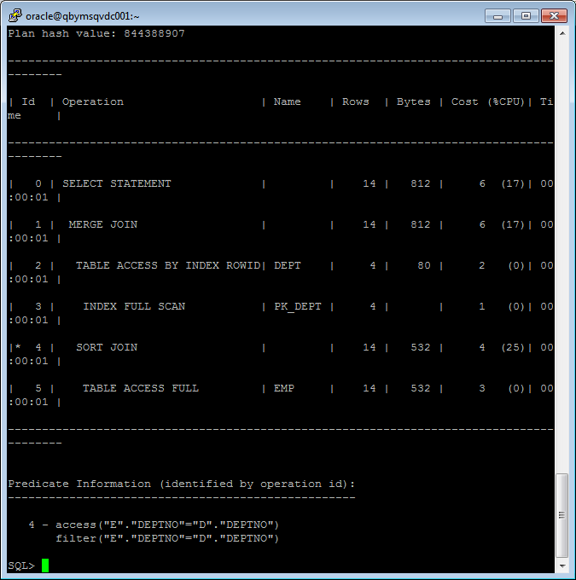

**Note:**  If you would like change in execution plan the type of join method use oracle performance hints. (USE_MERGE)

## Task 4: Hash Joins

**Task:** Prepare SQL **explain plan** using software: Oracle SQL Developer.

SELECT /*+ USE_HASH (d e) */ * FROM scott.emp e, scott.dept d WHERE e.deptno = d.deptno;

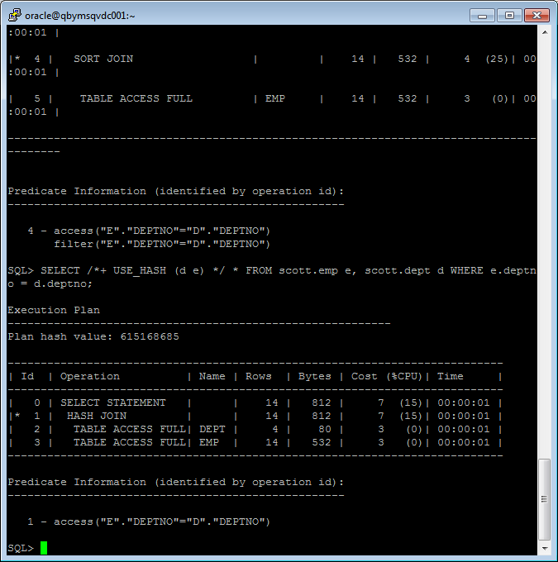

**Note:**  If you would like change in execution plan the type of join method use oracle performance hints. (USE_HASH)

## Task 5: Cartesian Joins

**Task:** Prepare SQL **explain plan** using software: Oracle SQL Developer.

SELECT * FROM scott.emp, scott.dept;

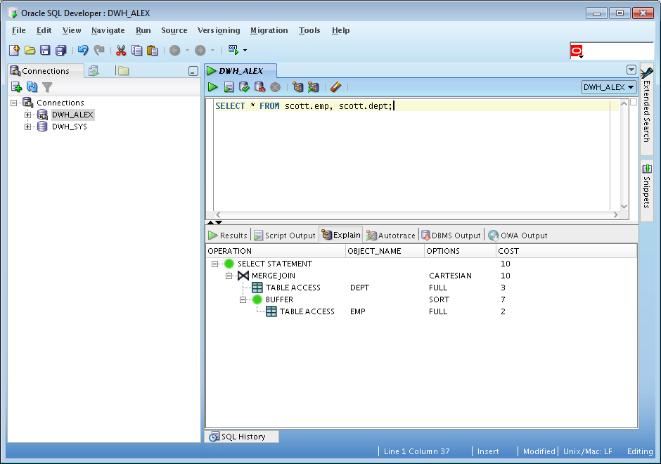

## Task 6: Left/Right Outer Joins

**Tasks:**

* Prepare SQL **trace protocol** using software: Oracle SQL Developer.
* Create SQL left outer join

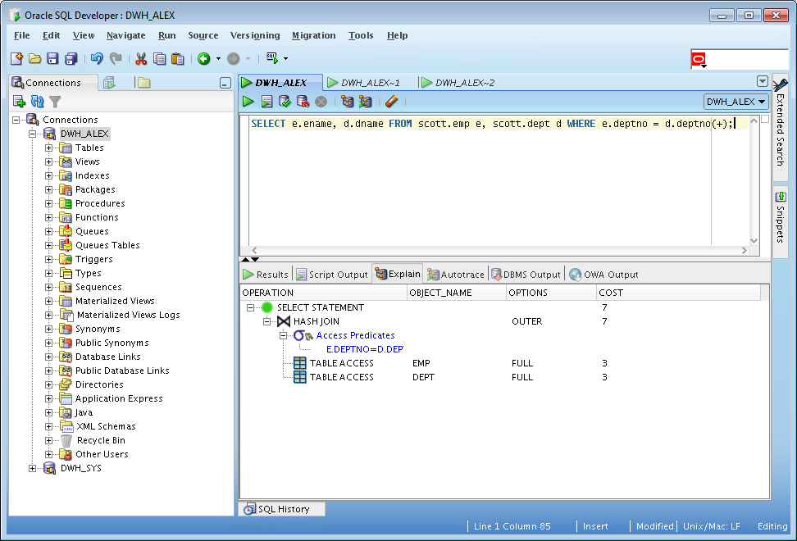

* Create SQL right outer join

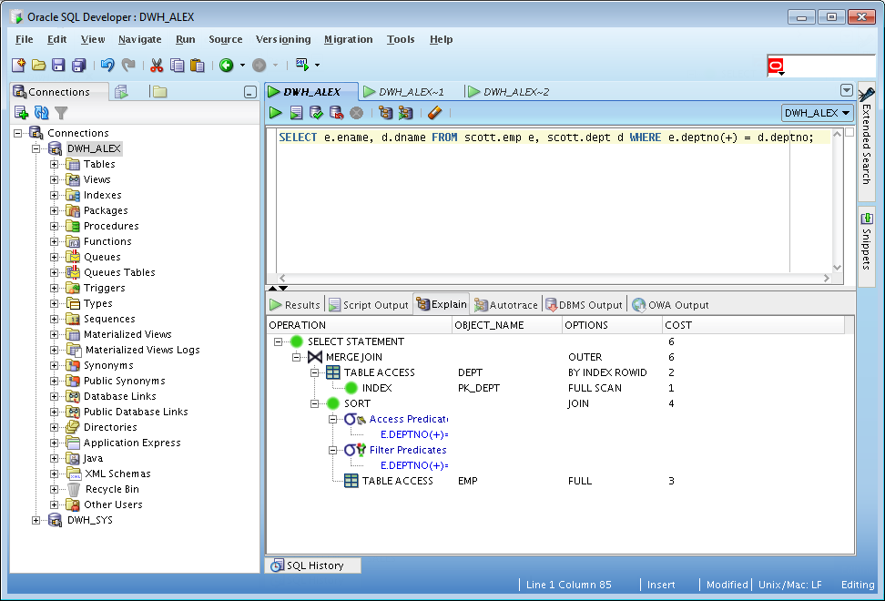

## Task 7: Full Outer Join

**Task:** Prepare SQL **explain plan** using: SQL plus Auto Trace Utility.

select e.ename, d.dname from scott.emp e full outer join scott.dept d on e.deptno = d.deptno;

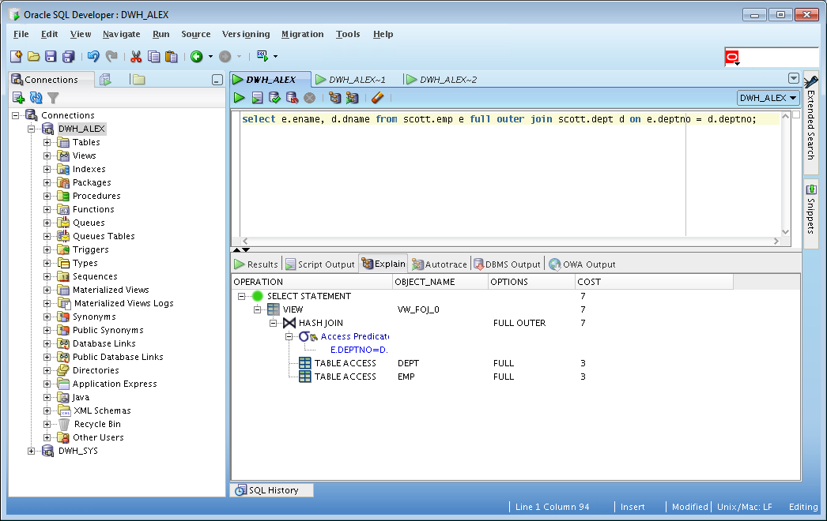

## Task 8: Semi Joins

**Task:** Prepare All possible variants of SEMI JOIN SQL **explain plan** using: SQL plus Auto Trace Utility.

**Note:**  If you would like change in execution plan the type of join method use oracle performance hints.

1. SEMIJOIN – perform a semi-join (the optimizer gets to pick which kind)

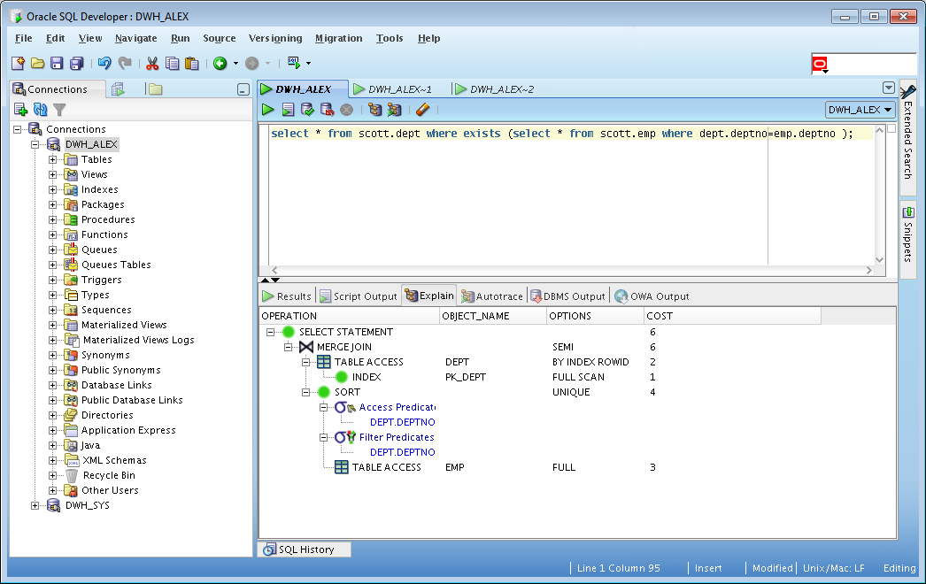

1. NO_SEMIJOIN – obviously means don’t perform a semi-join

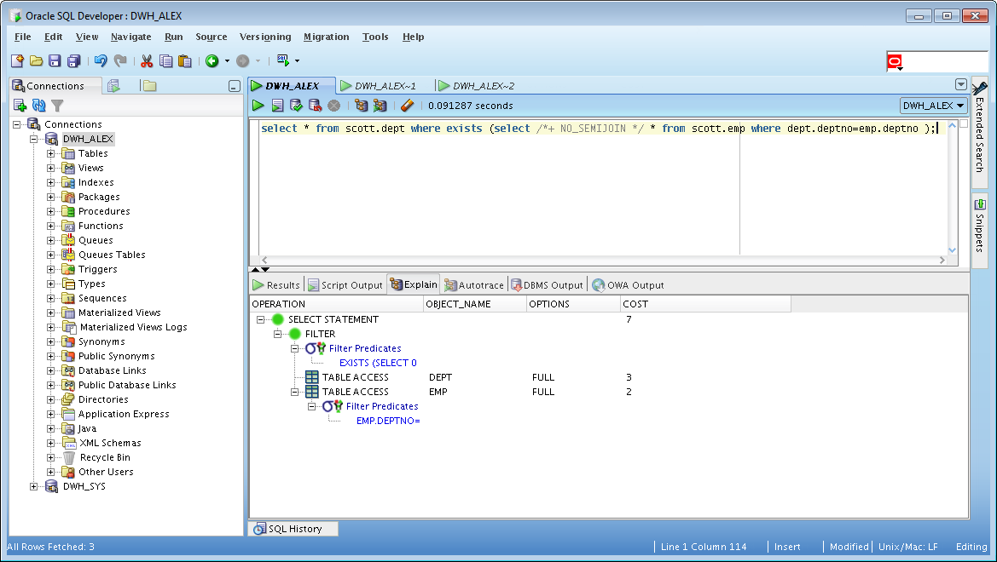

1. NL_SJ – perform a nested loops semi-join (deprecated as of 10g)

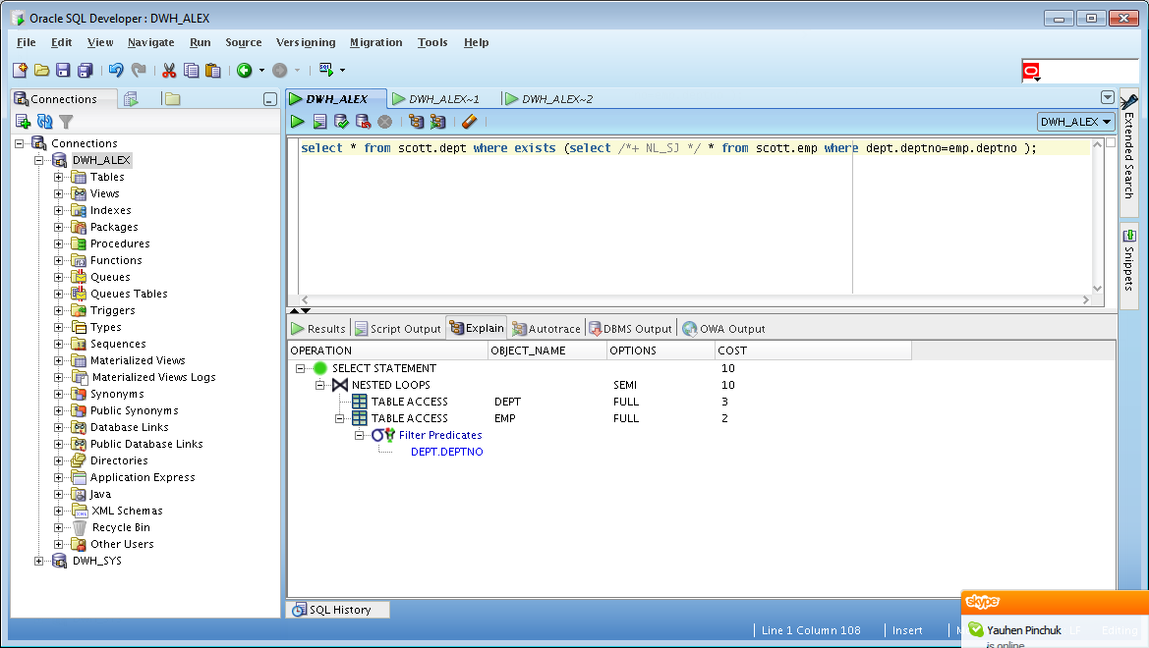

1. HASH_SJ – perform a hash semi-join (deprecated as of 10g)

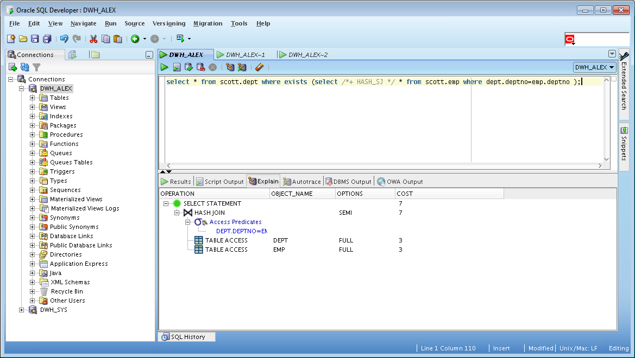

1. MERGE_SJ – perform a merge semi-join (deprecated as of 10g)

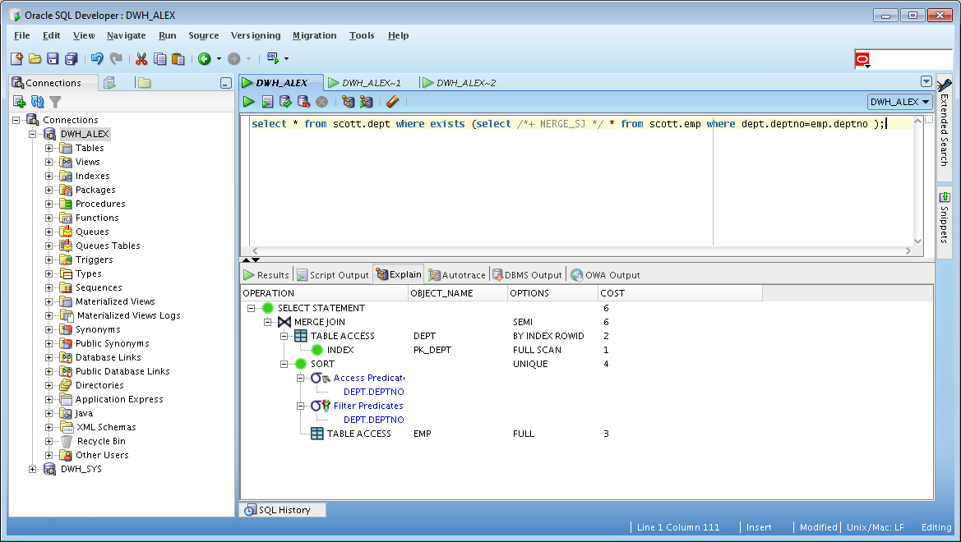

## Task 9: Anti Joins

**Task:** Prepare All possible variants of ANTI JOIN SQL **explain plan** using: SQL plus Auto Trace Utility.

**Note:**  If you would like change in execution plan the type of join method use oracle performance hints.

1. ANTIJOIN – perform an anti-join (the optimizer gets to pick which kind)

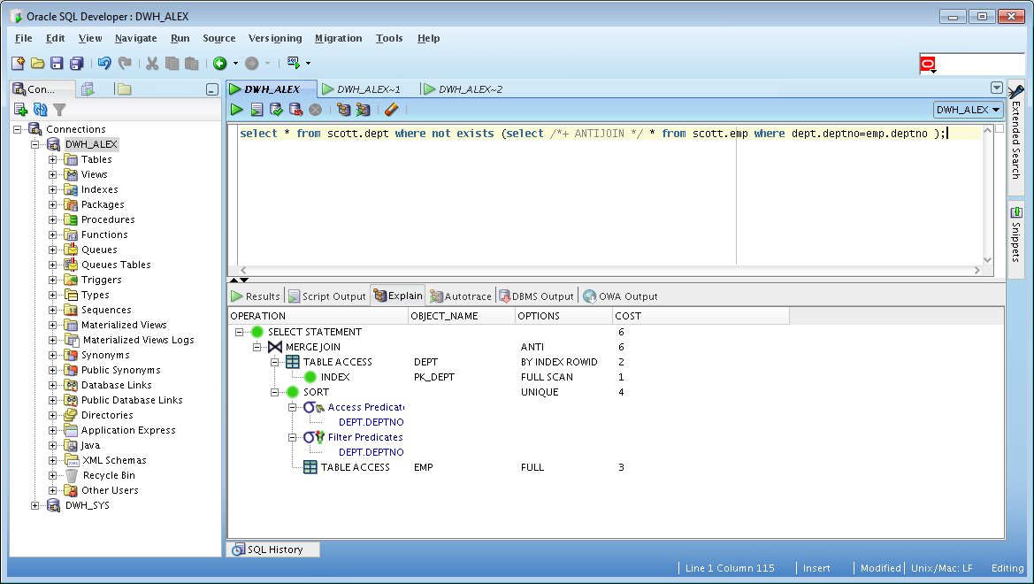

1. USE_ANTI – older version of ANTIJOIN hint

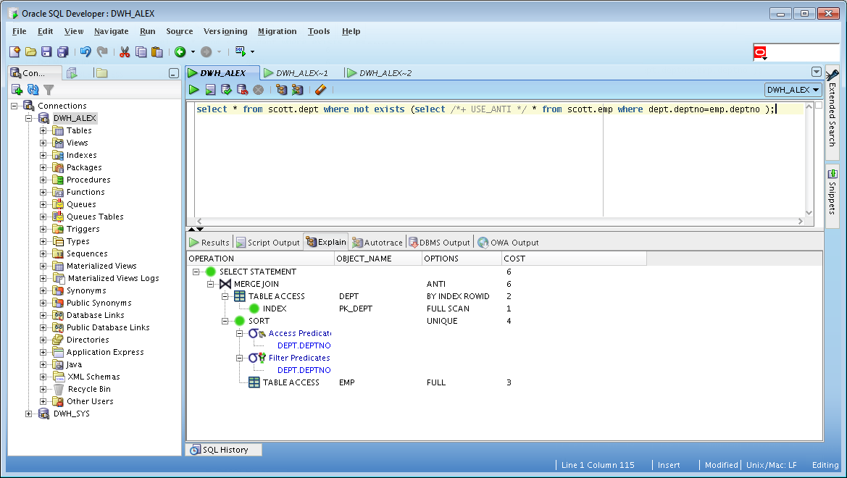

1. NL_AJ – perform a NESTED LOOPS anti-join (deprecated as of 10g)

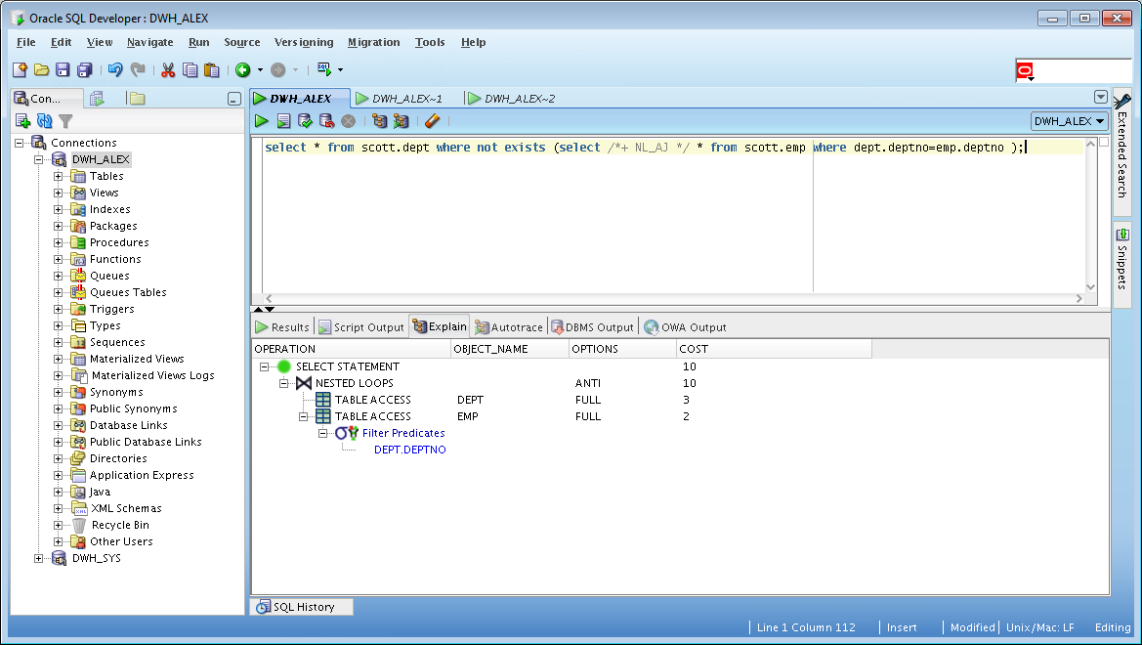

1. HASH_AJ – perform a HASH anti-join (deprecated as of 10g)

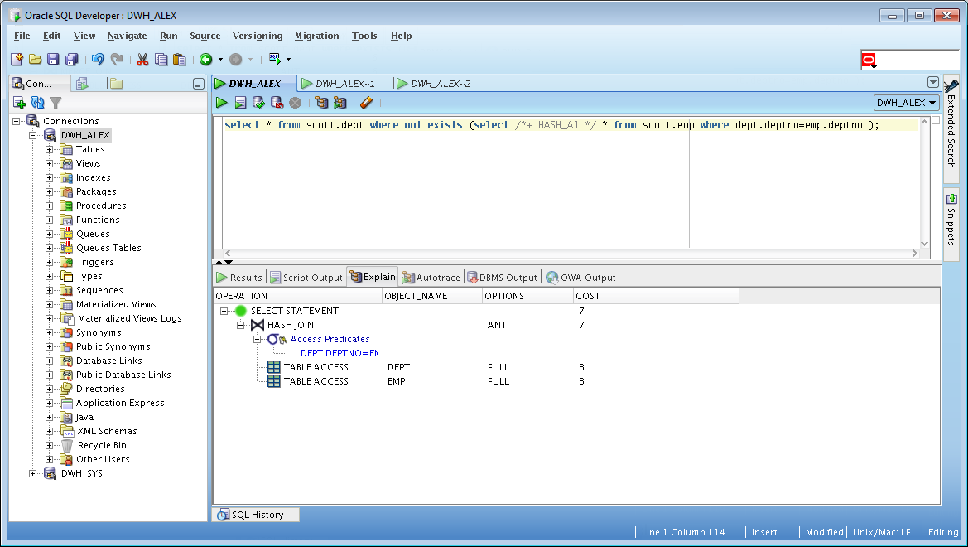

1. MERGE_AJ – perform a MERGE anti-join (deprecated as of 10g)

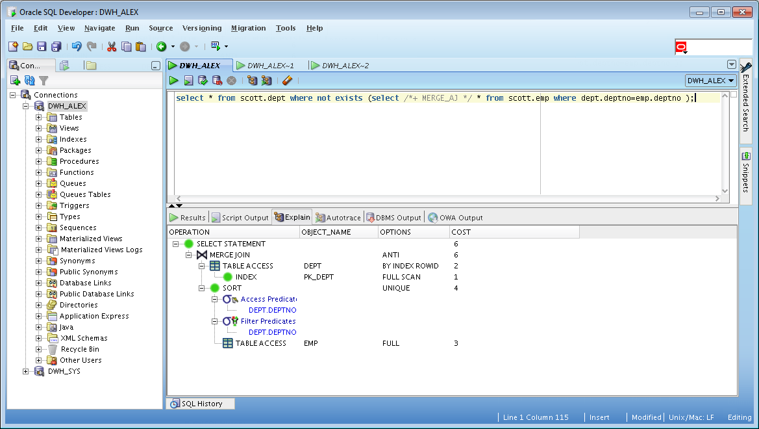

## Task 10: Prepare summary table

**Task:** Make comparison of all possible variant of join methods and join access methods and fill the table below:

|  |  |  |
| --- | --- | --- |
| Nested Loop | Hash Join | Sort-Merge Join |
| При NESTED LOOP одна таблица выбирается как внешняя, а другая — как внутренняя. Для каждой строки внешней таблицы обнаруживаются все строки внутренней таблицы, удовлетворяющие условию соединения. Это может быть чрезвычайно эффективно, если внутренняя таблица имеет индекс на столбец соединения, а во внешней таблице строк немного. | HASH JOIN особенно полезен, когда для соединяемых столбцов нет индексов. | Удобно использовать когда соединяемые таблицы отсортированы, иначе затраты на сортировку могу оказаться неприемлемо высокими. Так же удобно при больших размерах таблиц. |